Parul Institute of Engineering & Technology

Electronics & Communication Engineering Department
ASSIGNMENT-6

Subject Name: DIGITAL ELECTRONICS
Subject Code: 203105201

Programmable Logic Devices:
- Introduction to PLD and its types.
- Compare RAM, ROM and EPROM.
- Compare PLA and PAL.
- Write short note on Programmable Logic Arrays.
- Write short note on State machine on a Chip.
- What is FPGA? Explain its basic structure.
- A combinational circuit is defined by functions:
F1 (A, B, C) = Σ (3, 5, 6, 7)
F2 (A, B, C) = Σ (0, 2, 4, 7)
Implement the circuit with PLA having three inputs, four product term and two outputs.
- Using the simplified connection format of PLA, Show how an 8×1 PROM should be programmed to implement the logic function
F (A, B, C) = Σ (1, 4, 5, 7)

- Show how the PLA would be programmed to implement the functions. PLA having three inputs, four product term and two outputs.
F1=A(BC)’+ABC F2=ABC+(AB)’+AC’

- Using the simplified connection format of PLA, Show how an 8×1 PROM should be programmed to serve as a look-up table for the odd parity-bit of a 3 bit number? Use the simplified connection format of PLA.
- Show how the FPLA Circuit would be programmed to implement F1= A’BC’+B’C+ABC
- Implement the state diagram shown in fig. using PLS (Programmable Logic Sequencer )

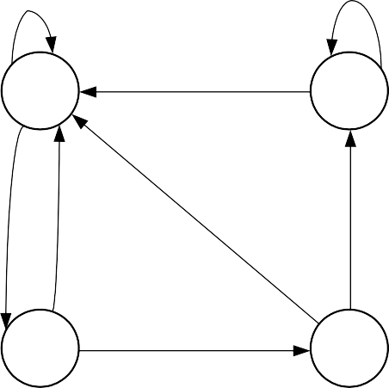
1/
0/0
1/0
0/1
00
10
0
0/1
0/1
1/0
1/0
01
11

